Sep 15, 2025
Kim Lawyer
Version 2.0

Instructions for BladderMin, a bladdermin structure automation script
The purpose of this script is to automate the process of creating the Bladdermin structure used for prostate patients or other treatment sites that require or benefit from bladder filling. The script will create a new low-resolution Bladmin_AUTO structure, with the user-selected protocol, with or without elective nodes. The main algorithm relies on a margin reduction while maintaining most of the overlap of a low dose isodose structure. It also applies some smoothing to help reduce manual adjustments of the structure after creation.
Table of Contents
- Importing\Launching the Script in Eclipse | 1
- Using the Script | 2
- After Running the Script | 3

Importing\Launching the Script in Eclipse
- Go to the External Beam Planning workspace. The script must be run from this workspace.
- If you have previously configured the script for Eclipse, skip to Step (3), otherwise:
  - Click on the Tools option from the menu, and select Scripts…
  - Click the radio button next to the Folder (if not already selected)
  - Click the Change Folder… button
  - Enter \\spvaimapcn\data$\VarianScripting\Bladdermin\ into the Folder: textbox, and click Open
  - 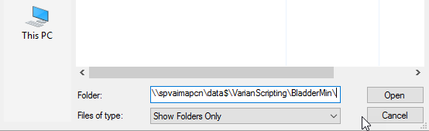
  - The Bladdermin.esapi.dll script should now appear in the Scripts window
  - If you wish, you can go to the Favorites window to choose a keyboard hotkey for future use, but this is not necessary.
- Pull your structure set or plan into current view, if it is not already active.
- Activate your shortcut or click on the Tools menu, and select the Bladdermin script

Using the Script
- The script window should now be visible. If you do not see it, check your other screens, it sometimes pops up in a random location.
- Verify the Current Plan and Current Structure Set at the top of the script.
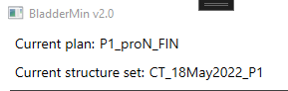
- Select the protocol from the drop-down menu:
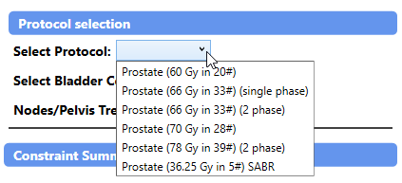
- If a 2 phase protocol is selected, a drop down will appear for the user to select the required Plan Sum.
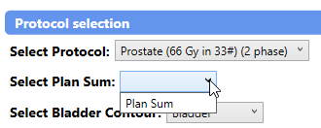
- Select the bladder contour if different from the defaulted one shown.
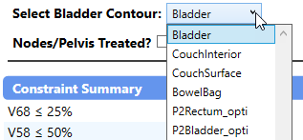
- Select the check box (if applicable) if nodes/pelvis are being treated.
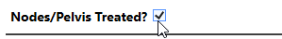
- Once a protocol is selected, the Constraint Summary window will populate the constraint values (adapted from bladder constraints) of the bladdermin structure. The Constraint Summary will automatically update depending on whether the nodes/pelvis checkbox was selected.
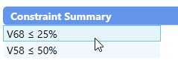
- Click on the Create BladderMin! button to start the structure generation.
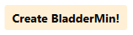
- Once the script has created the structure, it will display the Bladdermin structure volume, as well as the margins the script used should the user decide they would like to do this manually.
- Close the script and you should have your structure created!
- Note: manual adjustment of the bladdermin structure may be required post generation to better suit clinical needs.
After Running the script:
- The Bladmin_AUTO structure will need to be copied over to clinical BladderMin structure prior to manual adjustments.
- Once copied into the clinical Bladdermin structure, manual adjustments can be made as necessary in the Contouring workspace.
- Do not delete the Bladmin_AUTO structure as it could be useful for future evaluations. Just leave it and its naming convention, as it will be clear that this is a script-produced structure.

Admin Management of Bladdermin:
- Create a directory to store all the BladderMin protocols.
- Ensure the Configuration.xml file is in the same directory as the BladderMin.esapi.dll file. The script will not run otherwise.
- Open the Configuration.xml file and edit the <Protocols> tag to include the directory where all the protocol templates will be saved. Save the change. An example is shown below. This Configuration file allows the center to place their protocols anywhere they want, and updates can be made to this simple text file without need to go into the Bladdermin source code.
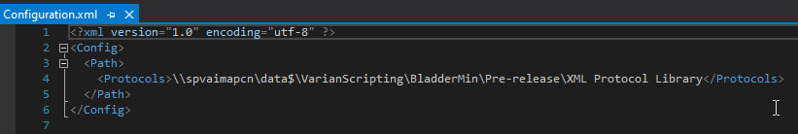

Generating Bladdermin Protocols:
- The protocols are written in .xml format with elements and attributes that contain the relevant information. A complete example is given below.
- All Bladdermin protocols are enclosed within the <BladderminProtocol> element. There are 2 main elements with the following attributes:
  - <ProtocolMetaData>
    - Name = the name of the protocol that the script will populate in the Select Protocol drop-down menu
    - NodesTreatable = indicates whether the checkbox to allow for nodal involvement will be visible on the script user interface. Allowable options are “true” and “false”.
    - MultiPhase = indicates whether the protocol is multiphase or not and therefore will cause the script to operate on a plan or plan sum. Allowable options are “true” and “false”.
  - <Constraints>
    - Nodes = indicates whether nodes are treated or not, which can determine which set of constraint values to use if the constraint values are nodal dependent. Default is “false” if NodesTreatable is set to “false”.
    - Multiphase = indicates whether it’s multiphase or not. Must be set to “true” if MultiPhase is “true”. Default is “false” otherwise
    - Constraints = defines the constraints for the protocol. One <constraint> attribute is needed per constraint. Within each <constraint> are the following attributes:
      - Name = the name of the constraint which displays on the script user interface
      - DoseValue = the dose value for the constraint.
      - DoseUnit = the units for the dose. Units should coordinate with the dose value.
      - VolumePresentation = Relative or Absolute
      - Volume = volume constraint. Value coordinates with VolumePresentation
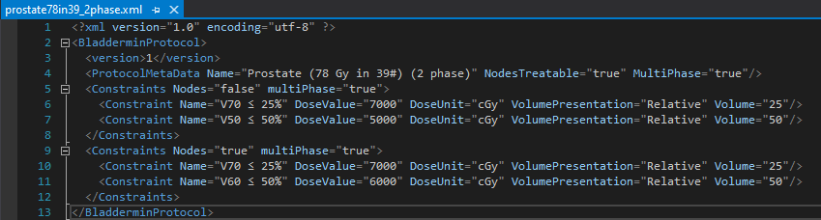
- An example protocol shown is below for a 2-phase, optional nodal involvement prostate 78Gy in 39fx:

